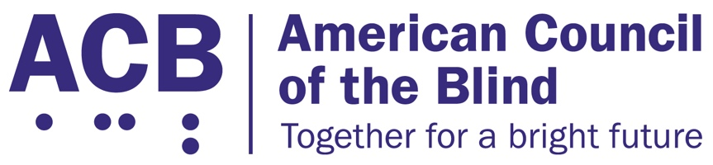
1703 N. Beauregard St., Suite 420

Alexandria, VA 22311

Tel: (202) 467-5081

Fax: (703) 465-5085

April 10, 2020

The Honorable Nancy Pelosi, Speaker
United States House of Representatives
1236 Longworth House Office Building
Washington, D.C. 20515

The Honorable Mitch McConnell, Leader
United States Senate
317 Russell Senate Office Building
Washington, D.C. 20510

The Honorable Kevin McCarthy, Leader
United States House of Representatives
2468 Rayburn House Office Building
Washington, D.C. 20515

The Honorable Charles Schumer, Leader
United States Senate
322 Hart Senate Office Building
Washington, D.C. 20510

Re: Congress Must Protect the Voting Rights of People with Disabilities

Dear Speaker Pelosi and Leaders McConnell, McCarthy, and Schumer:

The American Council of the Blind and the undersigned organizations actively represent and work to advance civil rights for people with disabilities. We write to express our concern that the CARES Act, H.R. 748, fails to reinforce to states that they must ensure equal access to federal elections for voters with disabilities when administering funds pursuant to this Act. The basis of our great democracy is the fundamental right to privately and independently mark, cast, and verify a ballot. Through passage of the Voting Rights Act, the Americans with Disabilities Act (ADA), and the Help America Vote Act, Congress mandated that states must ensure all voters are afforded full and equal access to the ballot box, whether at a polling location or voting remotely. Yet, voters with disabilities are routinely disenfranchised in absentee voting programs that require the voter to cast a paper ballot for federal elections. To complete a paper ballot one is required to, at the least, read standard text, physically write and/or fill in the ballot choices, seal and certify the ballot via a signature on the envelope, and mail the ballot back to the appropriate voting official to be counted. Each of these steps may act as a barrier to voting for voters who are blind and disabled.

There is no nationwide approach to creating accessible absentee ballots and as such, many voters with disabilities are excluded from absentee ballots. Some states have implemented accessible solutions to this problem, such as remote voting through the use of online and remote ballot marking devices. For example, earlier this year Gov. Justice in West Virginia signed into law S.B. 94, a bill to bring the absentee vote by mail system in West Virginia into compliance with Title II of the ADA by offering an accessible electronic absentee voting option for people with disabilities. These changes are the result of the tireless work of advocacy organizations and, in some cases, legal action. These ad hoc decisions by states to protect voting rights create an uneven landscape where voters with disabilities in some states may successfully cast a private, independent absentee ballot, while voters with disabilities in other states cannot, for the same federal election. Readily available solutions already exist that afford people with disabilities full and equal access to absentee or remote voting through the use of online and remote ballot marking devices.

This year marks the 30th anniversary of the Americans with Disabilities Act, and it is once again incumbent on Congress to reinforce the American principle that federal elections must be administered in an equitable manner, enabling voters with disabilities to cast a private, independent ballot. We strongly urge Congress to remedy the current disenfranchisement of voters with disabilities by requiring an accessible, secure online option by which people with disabilities may privately and independently mark, cast, and verify their ballots in any future COVID-19 relief legislation where federal election funding is allocated.

Sincerely,

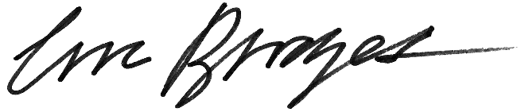

Eric Bridges
Executive Director
American Council of the Blind

American Association of People with Disabilities
American Foundation for the Blind
Asian Americans Advancing Justice – AAJC
Association of Assistive Technology Act Programs
Association for Education and Rehabilitation of the Blind and Visually Impaired
Association of University Centers on Disabilities
Autistic Self Advocacy Network
Blinded Veterans Association
Disability Rights Education & Defense Fund
Disability:IN
National Association of Councils on Developmental Disabilities
National Association of the Deaf
National Council on Independent Living
National Disability Rights Network
Paralyzed Veterans of America
Prevent Blindness
Self-Advocates Becoming Empowered
United Spinal Association
VisionServe Alliance
Washington Lawyers’ Committee for Civil Rights and Urban Affairs
ACB of Virginia
Alabama Disabilities Advocacy Program
American Council of the Blind of Indiana
American Council of the Blind of Maryland
American Council of the Blind of Nebraska
American Council of the Blind of New York
American Council of the Blind of Ohio
American Council of the Blind of Texas
Arizona Council of the Blind, Inc.
Bay State Council of the Blind
Braille Revival League
California Council of the Blind
Council of Citizens with Low Vision International
Disabilities Law Program of Community Legal Aid Society, Inc.
Disability Law Colorado
Disability Rights California
Disability Rights Center - New Hampshire
Disability Rights Florida
Disability Rights Iowa
Disability Rights Maine
Disability Rights Nebraska
Disability Rights New Mexico
Disability Rights Ohio
Disability Rights Texas
Disability Rights Vermont
Disability Rights Wisconsin
Florida Council of the Blind
Georgia Council of the Blind
Greater Louisville Council of the Blind
Guide Dog Users, Inc.
Illinois Assistive Technology Program
Illinois Council of the Blind
Independent Visually Impaired Entrepreneurs
Indiana Statewide Independent Living Council
Iowa Council of the United Blind
Kentucky Council of the Blind
Kentucky Council of Citizens with Low Vision
Louisiana Association for the Blind
Michigan Council of the Blind and Visually Impaired
Michigan Protection & Advocacy Service, Inc.
Middle Tennessee Council of the Blind
Missouri Council of the Blind
Mountain State Council of the Blind (West Virginia)
New York Association on Independent Living
North Carolina Council of the Blind
North Dakota Association of the Blind
Northern Kentucky Council of the Blind
Pennsylvania Council of the Blind
People First Wisconsin
Protection and Advocacy for People with Disabilities, Inc.
Randolph-Sheppard Vendors of America
State of Georgia Vision Alliance
South Dakota Association of the Blind
Tennessee Disability Coalition
Utah Council of the Blind
Washington Council of the Blind
Wisconsin Council of the Blind & Visually Impaired

