At Disability Rights Nebraska, we are committed to inclusivity and meaningful engagement of people with disabilities. Our strategic plan for Fiscal Years 2024-2028 sharpens our emphasis on three focus areas: Freedom from Harm, Most Inclusive Settings, and Engaging People with Disabilities in Advocacy.

We strive to involve people with disabilities in all aspects of our work, whether as participants, trainers, or personal experts in their life experiences. We challenge other organizations and policy-setting groups to similarly engage people with disabilities in meaningful roles.

We value your input on our focus areas for the Fiscal Year 2026. Please take a few minutes to complete our survey by July 31, 2025. Your feedback is essential to us.

For assistance or to request the survey in an alternative format, please contact our office at 800-422-6691.

Thank you for your time and contributions!

**PROPOSED PRIORITIES, GOALS AND OBJECTIVES FY 2026**

**FOCUS AREA – FREEDOM FROM HARM**

**Goal 1A: Identify, monitor and advocate for change in places where people with disabilities learn, live and work.**

**1A.1:** Maintain a regular presence at the Beatrice State Developmental Center

(BSDC), including documentation available to us.

**1A.2:** Maintain a regular presence at the Lincoln Regional Center (LRC) at least twice a month.

**1A.3:** Monitor at least 25 settings where people with disabilities are segregated, isolated, and congregated.

**1A.4:** Implement the Protection and Advocacy for Beneficiaries of the Representative Payee Program.

**Goal 1A:**  Not Important  Important  Very Important

Comments:

**Goal 1B: Investigate and respond to allegations of abuse, neglect and exploitation using a range of approaches to ensure that vulnerable people with disabilities are free from harm.**

**1B.1:** Investigate and respond to at least 35 allegations of abuse, neglect, or exploitation through systemic advocacy, individual advocacy, limited advocacy, and self-advocacy assistance.

**1B.2:** Engage in two activities to address areas where public policy could strengthen protections from harm for people with disabilities.

**1B.3:** Investigate and respond to systemic inappropriate use of restraint and seclusion at the Lincoln Regional Center.

**1B.4**:Conduct three training and outreach activities to educate facilities and entities about the access authority of Disability Rights Nebraska.

**Goal 1B:**  Not Important  Important  Very Important

Comments:

**FOCUS AREA – MOST INCLUSIVE SETTINGS**

**Goal 2A: Investigate and respond to allegations of rights violations that impede people with disabilities from learning, living and working in the most inclusive settings.**

**2A.1:** Address at least 50 alleged violations of the Americans with Disabilities Act, Section 504 of the Rehabilitation Act, the Individuals with Disabilities Education Act, the Fair Housing Act, and the Nebraska Fair Housing Act through systemic advocacy, individual advocacy, limited advocacy, and self-advocacy assistance.

**2A.2:** Provide individual advocacy, limited advocacy, and self-advocacy assistance to at least five individuals in need of assistive technology and related services.

**2A.3:** Assist at least 10 beneficiaries of Social Security facing barriers to employment though individual advocacy, limited advocacy and self-advocacy assistance.

**Goal 2A:**  Not Important  Important  Very Important

Comments:

**Goal 2B: Advocate for people with disabilities to learn, live and work in the most inclusive settings.**

**2B.1:** Engage in a range of advocacy efforts, including collaboration with relevant organizations, to address the Olmstead Plan including the need for integrated housing and services for people with serious mental illness.

**2B.2:** Conduct three educational activities to address the employment of people with disabilities, including sub-minimum wage, competitive integrated employment, supported employment and the Medicaid Insurance for Workers with Disabilities program.

**2B.3:** Continue to research barriers to being served in the most integrated setting experienced by children and youth with mental illnesses who are in residential treatment facilities, including juvenile justice facilities and conduct monitoring visits to4 identified facilities.

**2B.4:** Conduct three educational activities to address Home and Community-Based Services and affordable, accessible housing for people with disabilities.

**2B.5:** Raise awareness of the needs of the most vulnerable people with disabilities and the work we do by conducting outreach through relationship building, presentations, events/tabling, materials and other methods.

**2B.6:** Organize, educate, and provide on-going support to ordinary citizens across Nebraska to become effective lay advocates for inclusive education opportunities for students with disabilities.

**2B.7:** Engage in three educational activities to address disability within emergency management, planning and response.

**Goal 2B:**  Not Important  Important  Very Important

Comments:

**FOCUS AREA - ENGAGING PEOPLE WITH DISABILITIES IN ADVOCACY**

**Goal 3A: Provide opportunities for people with disabilities to learn about being effective advocates and support them in advocating about things that impact their lives.**

**3A.1:** Provide two opportunities for people with disabilities to become engaged in disability-related public policy research, education, and advocacy.

**3A.2:** Continue to educate and raise awareness regarding Supported Decision-Making in Nebraska.

**3A.3:** Conduct outreach and inform at least 700 people with disabilities about their voting rights.

**Goal 3A:**  Not Important  Important  Very Important

Comments:

|  |  |  |
| --- | --- | --- |
| **Tell us about yourself:** | Person with a disability  Family Member  Advocate | Service Provider  Professional  Other (Please explain) |
| **Ethnicities** | Ethnicity Unknown  Hispanic/Latino | Not Hispanic/Latino  Not Selected |
| **Races** | Native American  Alaskan Native  Asian  Black / African American  India Indian  Native Hawaiian | Other Pacific Islander  Race Unknown  Two or more races  White  Other (Please explain) |
| **Do you live in an Urban or Rural area?** | Urban (Omaha, Lincoln, Bellevue, Grand Island) | Rural (All other Nebraska cities)  Unknown |

Any additional comments:

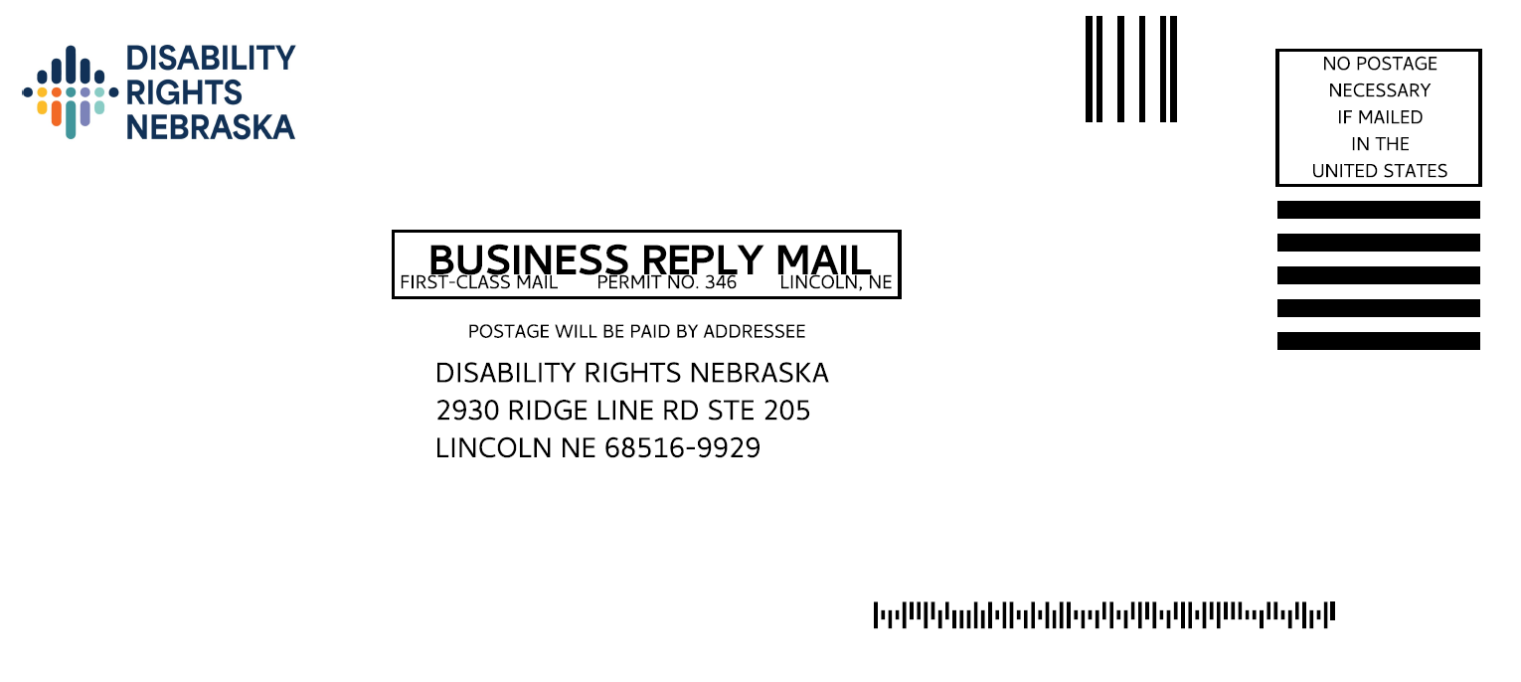

**THANK YOU!**

